FIERCE FIRESIDE CHAT INVITATION EMAIL

To: All Employees Who Have Attended Fierce Foundations
From: Internal Sponsor
Subject: Announcing Fierce Conversations: Fireside Chats
Body:

Hello Fierce Conversationalists!

Come join us for the first Fierce Fireside Chat on <Friday, April 16th, 1-2pm>.

At this quarterly 1-hour meeting you can:
- Connect with other Fierce trained members of our campus community
- Share how you have experimented with some of the tools learned from Fierce (wins and failures)
- Get peer support and feedback on some challenges or opportunities you may be facing
- Refresh your knowledge of the tools and techniques taught in the Fierce Conversations trainings
- Ask the community any post Fierce Training questions you may have developed

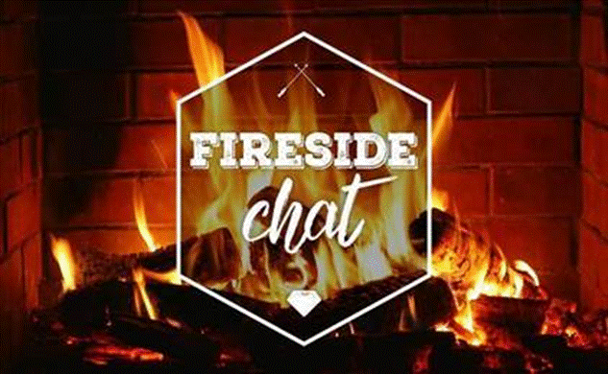

If you’re interested in joining any (or all) of these quarterly events, please register here:
<include internal registration link>

<Enter your future fireside dates here>
o April 16, 2021 – 1:00-2:00
o July 13, 2021 – 10:00-11:00
o October 21, 2021 – 3:00-4:00
o January 19, 2022 – 11:00-12:00

We look forward to connecting with you at our first Fierce Fireside Chat!

Note: There is no preparation needed to attend these fireside chats. You need only have taken the Fierce Foundations course. We will structure the hour with some icebreakers, breakout groups, and conversation starters.

Stay Fierce,
[Internal Sponsor]

